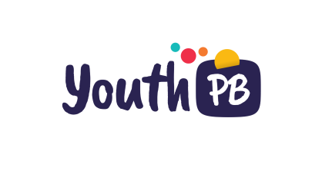
Participatory budgets that involve young people,
both in schools and in municipalities

Instructions: if you wish to incorporate your case into the participatory budgeting map on youthpb.eu, please complete the following information as completely as possible and send it to info@youthp.eu. We will contact you confirming its receipt and publication.

Basic information

Your name (person completing the form)

Your email (to confirm receipt)

Project name

Brief description of the project (300 characters maximum)

Logo (please provide a link from where this can be downloaded or email it directly to info@youthpb.eu)

Organizer’s name(s)

Project Website

Project Organizers contact email

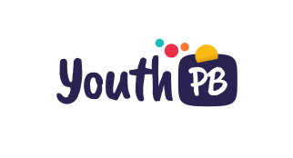
Estimated total cost of the project in euros (where known)

Budget allocated through the PB project (where known)

Type of Participatory Budget (e.g. school or municipal)

Start date

End date

Status:
- Completed
- On-going

Estimated number of participants

Age range of participants

How did participants decide which projects were funded? (e.g. voting, consensus, deliberation etc)

Method used for decision-making:
- Paper ballot
- on-line ballot
- paper and online

Project location

Locality

Province or region

Country

Address

Description of project
Preparation and design of process (for example, its purpose and intended outcomes, timescales, spaces for deliberation and debate, how it was organized and how was it facilitated)

Step-by-step implementation (for example, when young people were involved, who helped implement the process, techniques used to inform and promote participation, use of social networks, etc.)

How young people participated (for example, individually or in groups? Guided by facilitators, through voluntary participation or independently?)

Role of young people:
- Participants
- Beneficiaries (receive funding)
- Helpers
- Organizers
- Managers to deliver the process

What was successful or innovative about the project?

Main obstacles to the project

Opinions after implementation or from evaluation reports (e.g. was the project well received? Were there any criticisms? What might you do differently?)

Accountable bodies: where did the budget came from and who had final responsibility for ensuring that it was spent as planned?

Organizers Tips
1-3 recommendations (advice or warnings) from organizers or participants

Resources: Links to examples of application forms, voting papers, communication materials, curriculum resources, participatory games and tools or evaluation reports (please list individual resources with a separate link for each one)

Media coverage (please share links to reports of the process in public media, such as newspaper articles, television, radio, etc.)

Images. Please, submit them to info@youthpb.eu ensuring you identify the project, and any copyright restrictions or credits that need to be included.

